**AC LIGHT control by Bluetooth Module and RELAY**

Description: In this Project , we will control a AC LIGHT by using a Bluetooth Module and Relay.

**RELAY**:

What is RELAY?

= Relay is a kind of Switch by which we can control AC LIGHT by using ARDUINO .

It is used to control High Voltage Circuits with the help of LOW Voltage Signal.

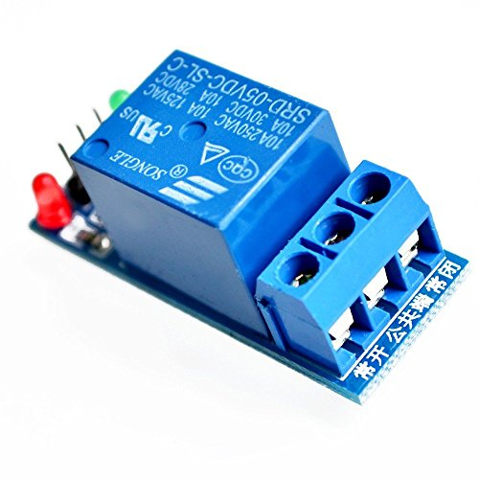 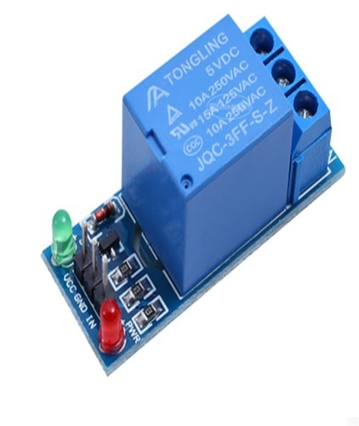

**Hardware Requirement:**

* Arduino Board
* Jumper wire
* 5V RELAY
* 12V Charger Cable
* AC BULB LIGHT
* Bread board
* Bluetooth Module

**CONNECTION:**

**RELAY CONNECTION:**

* Relay’s VCC pin connected to arduino’s 5V pin
* Relay’s GND pin connected to arduino’s GND pin
* Relay’s IN pin connected to arduino’s 8 pin
* Bulb’s one wire is cut into 2 parts and one part connected to Relay’s NC(Naturally Close) and other part connected to Relay’s C(Common)

**BLUETOOTH MODULE’s CONNECTION:**

* Bluetooth Module’s Vcc pin connected to arduino’s 5V pin
* Bluetooth Module’s Gnd pin connected to arduino’s gnd pin
* Bluetooth Module’s TXD pin connected to Arduino’s RX pin
* Bluetooth Module’s RXD pin connected to Arduino’s TX pin
* Charger connected to arduino’s INPUT Power supply

**Circuit Diagram:**

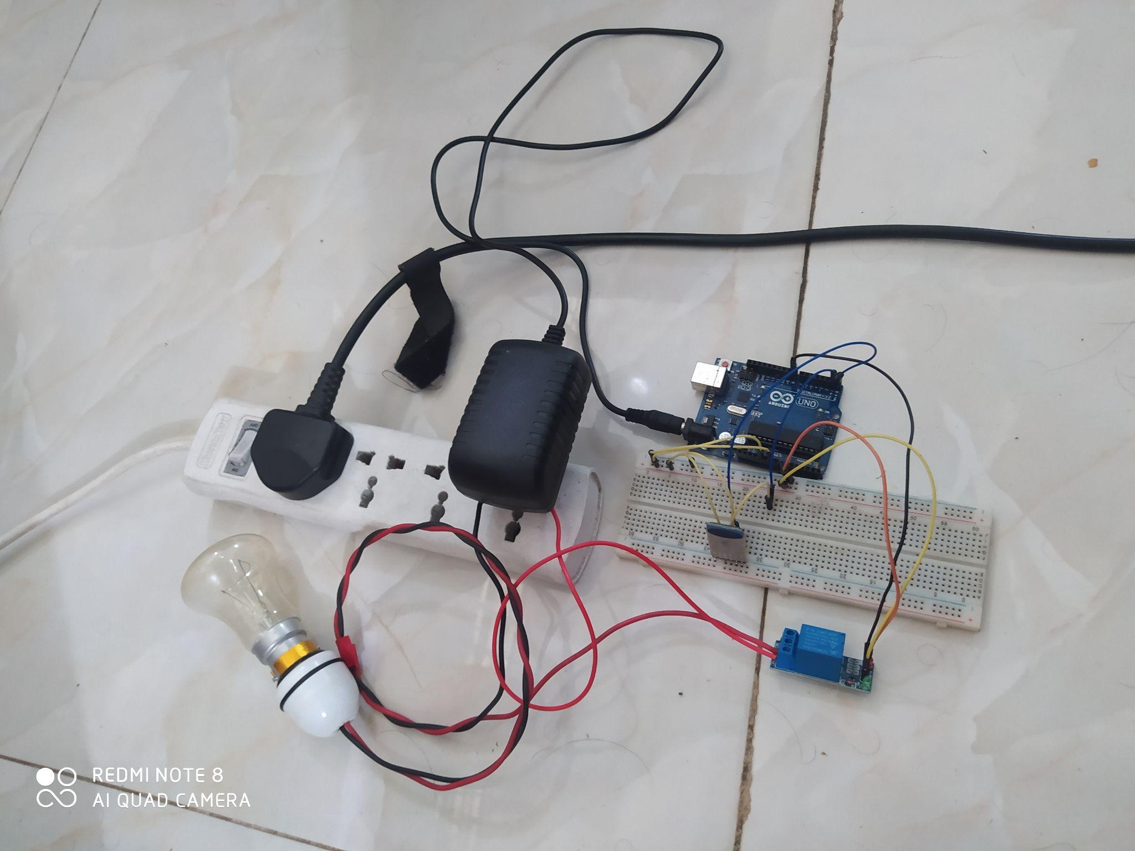

CODE:

| int pin=8; char state;   void setup() {  // put your setup code here, to run once: Serial.begin(9600); pinMode(pin,OUTPUT); }  void loop() {  // put your main code here, to run repeatedly: if(Serial.available()!=0) {  state=Serial.read(); } if(state=='1') {  digitalWrite(pin,HIGH); }  if(state=='2') {  digitalWrite(pin,LOW); } } |
| --- |

**OTHERS :**

1. Installthe bluetooth terminal in the mobile.
2. Then connect the bluetooth to the HC-05

**OUTPUT:**

1. If i write 1 in the terminal then the LIGHT brighten up
2. If i write 2 in the terminal then the LIGHT goes down.